

|  |
| --- |
|  |
| National Polymer Industries PLC. |
| **October 8 2024** |

**National Polymer Industries Group**

**MEHADI HASAN**

**BATCH-29 (OFFICE APPLICATION)**

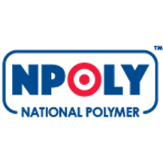

National Polymer Industries PLC.

**MEHADI HASAN**

**Department of Accounting & Information Systems**

**Batch: 29**

**Computer Fundamentals and Office Applications (CFOA)**

**Edge Digital Skill Training Course**

**Table of Contents**

**1.** **Executive Summary** 2

1.1. Company Objective 2

1.2 Mission and Vision 2

1.3 Core Values 2

**2.** **Products of National Polymer Industries PLC.** 3

2.1 Products category 3

2.2.1 Flow Chart of Business Plan 6

3.Flow Chart and Table Report 7

3.1. Statistics of sold products in the Product name wise 7

3.2. Sales Report of National Polymer Industries PLC. of the Month January – March 2024 8

3.3. Area wise sales report 8

4.Market Position 9

5.Recent Achievements 9

6.Challenges and Opportunities 9

7.Business Outlook 10

8. Conclusion 10

9. THANK YOU 11

# **Executive Summary**

## 1.1. Company Objective

* To promote quality products with the objective of setting a benchmark for industry practice;
* To promote and develop standards, specifications and practices that help to ensure the proper use of plastic products;
* To enhance knowledge and awareness of contemporary plastic pipeline technologies amongst the specifiers, installers and users; and
* To achieve excellence in people through creativity, research & development.

## 1.2 Mission and Vision

**VISION**

Our vision is to establish NATIONAL POLYMER INDUSTRIES PLC. as a role model in the Plastic Industry of Bangladesh with innovative quality products, services and solutions.

**MISSION**

Our corporate mission is to be the eminent manufacturer of the best quality products for our existing and potential customers through: Product leadership; Excellent value and Superior quality services.

## 1.3 Core Values

**Shareholders:** Create sustainable value for our shareholders by utilizing an honest and efficient business methodology;

**Customers:** Render quality services to our customers by using the state-of-the-art technology, offering diversified quality products to fulfill their needs to the best of our abilities;

**Employees:** Be reliant on the inherent talents of the employees. Work together to attain goal and reward the skills and talents of everyone at the work place; and

**Community:** To serve the society through employment generation with equal opportunities, support the community and be a responsible corporate citizen.

**Accountability:** We are accountable to provide the quality products & services to our valued customers along with meeting the regulatory requirements and ethical business practices.

**Respectfulness:** We are always respectful to our customers, shareholders & other stakeholders. We always appreciate comments & suggestions from our stakeholders

# **Products of National Polymer Industries PLC.**

## 2.1 Products category

National Polymer Industries PLC. offers a diverse range of products category:

**Upvc Fittings & Pipe**

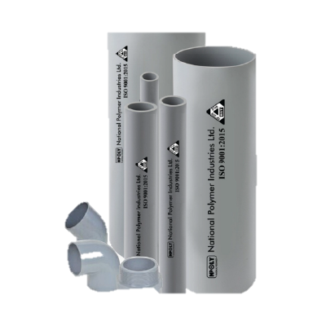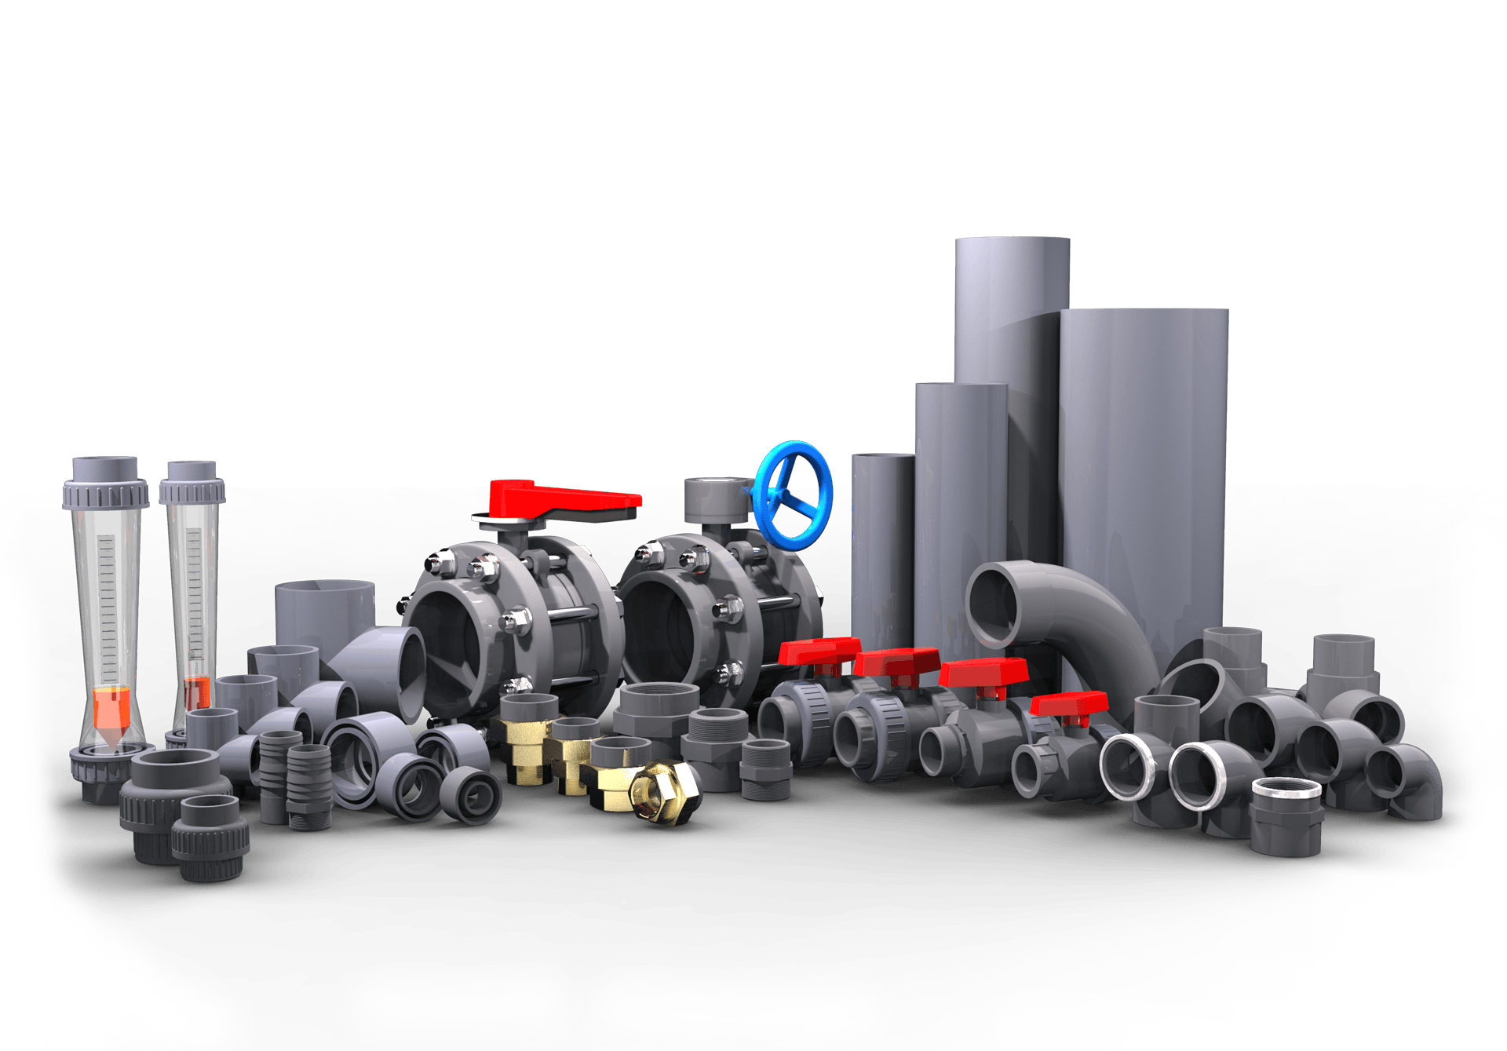

NPOLY upvc fittings & pipe are high quality performance with excellent installation properties. Upvc fittings and pipe is compatible for both hot and cold water distribution system.

**Water Tank**

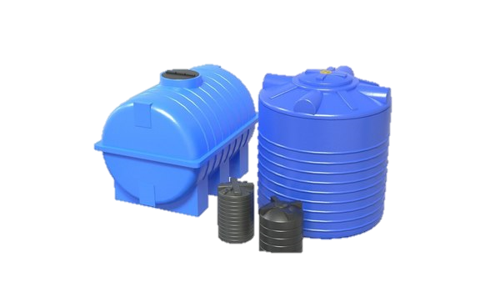

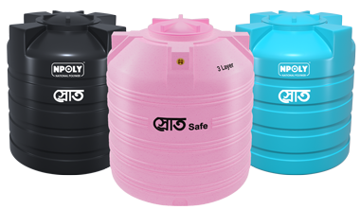

The color of the tank is not damaged by sunlight and heat. World class water tank with anti-bacterial ingredients.

**Upvc Door**

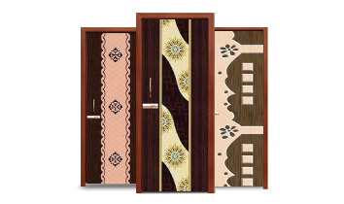

**

**Taplon Tape**

**Bathroom Fittings**

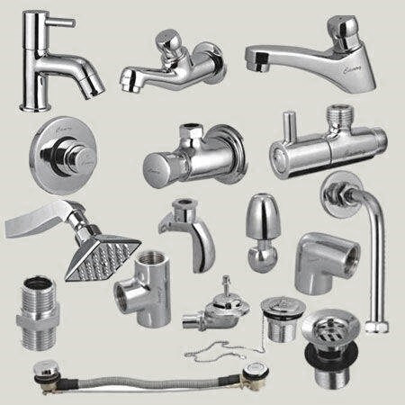

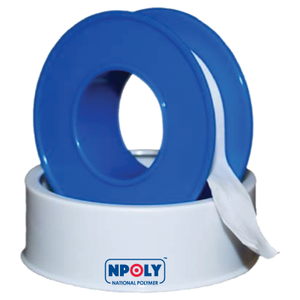

**Kitchen Sink**

**Gas Stove**

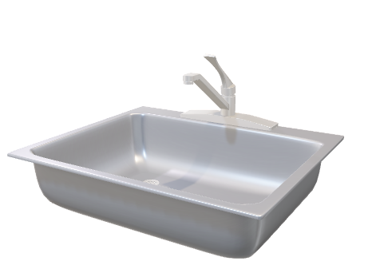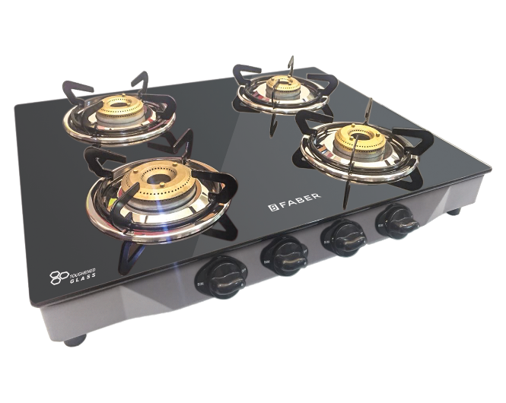

## Flow Chart of Business Plan

**National Polymer Industries PLC.**

# **3.Flow Chart and Table Report**

## 3.1. Statistics of sold products in the Product name wise

|  |  |
| --- | --- |
| **Product Name** | **Total** |
| **Bathroom Fittings** | **49958** |
| **Gas Stove** | **80331** |
| **Kitchen Sink** | **37656** |
| **Taplon Tape** | **29903** |
| **Upvc Door** | **38730** |
| **Upvc Fittings** | **288582** |
| **Upvc Pipe** | **73851** |
| **Water Pump** | **3485943** |
| **Water Tank** | **63218** |
| **Grand Total** | **4148172** |

## 3.2. Sales Report of National Polymer Industries PLC. of the Month January – March 2024

|  |  |
| --- | --- |
| **Month** | **Total** |
| **Jan** | **3835403** |
| **Feb** | **145286** |
| **Mar** | **167483** |
| **Grand Total** | **4148172** |

## [3.3. Area wise sales report](C:\\Users\\Ryans\\Downloads\\(BADHON DAS) EXCEL PROJECT.xlsx)

|  |  |
| --- | --- |
| **Area** | **Total** |
| **Barishal** | **306663** |
| **Chittagong** | **74760** |
| **Dhaka** | **116942** |
| **Khulna** | **3615495** |
| **Mymensingh** | **34312** |
| **Grand Total** | **4148172** |

# **4.Market Position**

With a strong domestic market presence, The company’s strategic partnerships and robust supply chain have enabled it to compete effectively in the global market.

# **5.Recent Achievements**

National Polymer Industries PLC (NPoly) has made notable achievements recently. In the fiscal period ending March 31, 2024, the company reported impressive sales growth. Third-quarter sales increased to BDT 2,039.03 million from BDT 1,814.16 million in the previous year, reflecting the company's expanding market reach. Revenue also saw a rise, hitting BDT 1,775.27 million. However, despite the increased sales, net income declined slightly to BDT 46.4 million, down from BDT 67.75 million a year ago​

Successfully launched a new product of Cpvc fittings & pipe.

# **6.Challenges and Opportunities**

* **Challenges:** The building products industry is highly competitive, both from domestic players and international brands. Maintaining a competitive edge in terms of quality and pricing can be difficult in such an environment​
* **Opportunities:** NPoly can explore opportunities by diversifying its product portfolio. Expanding into new lines such as high-tech polymer solutions for industrial or specialized applications could increase revenue streams​

# **7.Business Outlook**

National Polymer industries Ltd. is on a well-defined growth stage providing with the diversified quality products and efficient services to its valued customers. Crossing the national border, the Company has entered into the global markets- India and Middle East with its premium quality products. Despite different challenges and strong competition in the market, the Company has maintained its profitable status in terms of business. It is mentioned that, during the financial year 2020-2021 the Company achieved its revenue growth by 30.71% compared to the previous years.

# **8. Conclusion**

National Polymer Industries PLC (NPoly) has positioned itself as a key player in Bangladesh’s polymer-based building materials sector. With a strong presence in pipes, fittings, household items, and furniture, NPoly’s ability to adapt to market demands is reflected in its steady sales growth, with revenues increasing notably in 2024​.

# 6. THANK YOU

# 